Topic: Restaurant Application
Objective: To develop a native Restaurant Application using Flutter without any third-party libraries, focusing on clean UI, smooth user experience, and dynamic data integration using provided APIs.
App Structure
1. Splash Screen
- This is the entry point of the app.
- It displays the restaurant logo and a "Continue" button.
- On tapping the button, the user navigates to the Home Screen.
2. Home Screen
- Displays 7 cuisine categories in a horizontally scrollable card view (each card shows an image and the cuisine name).
- Tapping on a cuisine card opens the Cuisine Screen for that category.
- Shows the Top 3 Dishes in tile format (with image, price, rating, and option to add multiple quantities).
- Includes:
  - Cart button → opens the Cart Screen
  - Language switch → toggles between Hindi and English
3. Cuisine Screen
- Shows the list of dishes under the selected cuisine.
- Each dish includes:
  - Image, price
  - Buttons to increase/decrease quantity
  - Add to Cart functionality for each dish
4. Cart Screen
- Displays all dishes added from the selected cuisine.
- Shows:
  - Net total of all items
  - CGST & SGST at 2.5% each
  - Grand total (Net + Taxes)
  - Place Order button to complete the order

Screenshots:
1. Splash Screen 2. Home Screen
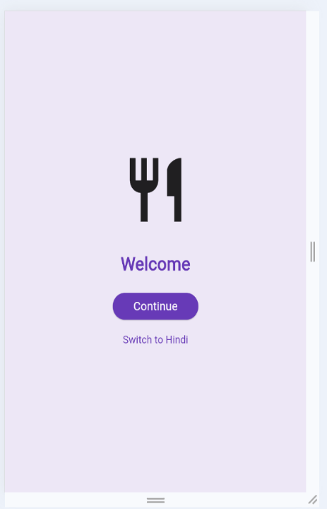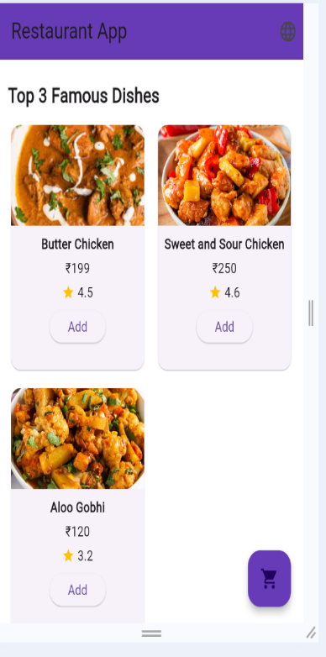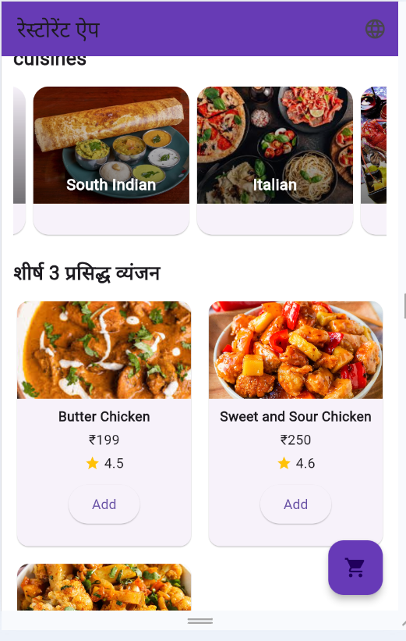

3. Cuisine Screen

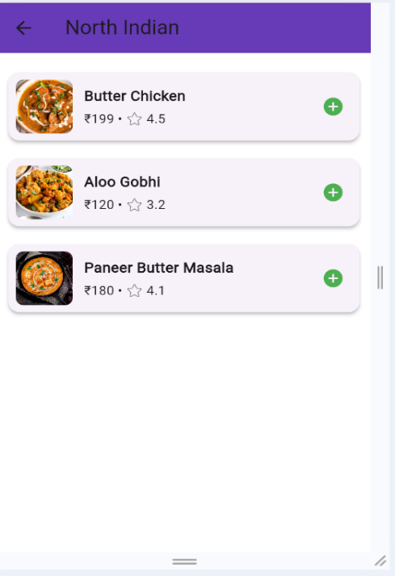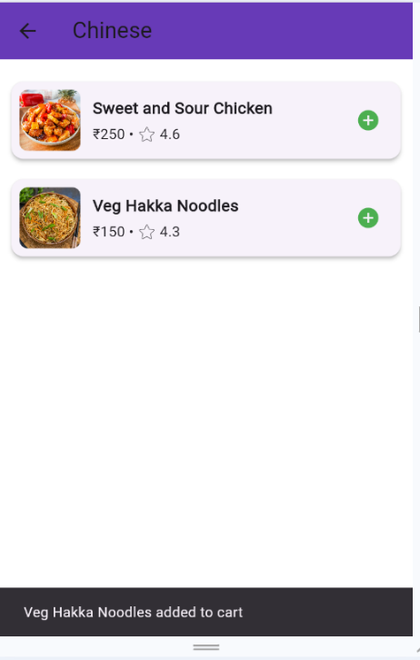

4. Cart Screen
